Project Proposal Report

Olivea K.T.
IT22267740

B.Sc. (Hons) Degree in Information Technology
Department of Software Engineering
Sri Lanka Institute of Information Technology

March 2026

Declaration
I declare that this is my own work and this proposal does not incorporate, without acknowledgment, any material previously submitted for a degree or diploma at any other university or higher education institution. To the best of my knowledge and belief, it does not contain any material previously published or written by another person except where acknowledgment has been made in the text.

Name | Student ID | Signature
Olivea K.T. | IT22267740 | 

The above candidate is carrying out research for the undergraduate Dissertation under my supervision.

Supervisor's Signature: ___________________
Date: ___________________

Acknowledgement
I would like to express our sincere gratitude to our research supervisor, Ms. Thilini Jayalath, for her continuous guidance, encouragement, and valuable insights throughout the development of this research proposal. Her expertise, constructive feedback, and support greatly contributed to shaping the direction and quality of this research work.
I also extend our heartfelt appreciation to our external supervisors,
4Ms. D. M. Dasunika Isurindi Dissanayake, Speech and Language Therapist and Visiting Lecturer at the Faculty of Medicine, University of Kelaniya, and Ms. Dinusha Fonseka, Speech and Language Therapist and Visiting Lecturer at the Faculty of Medicine, University of Kelaniya. Their professional knowledge and valuable advice regarding dyslexia and learning difficulties provided essential guidance for understanding the practical aspects of this research.
I would like to sincerely thank Ayati Trust Sri Lanka and the Ayati Centre, Faculty of Medicine, University of Kelaniya, for their support and for providing valuable opportunities to understand the challenges faced by children with dyslexia. The interaction with professionals and students associated with the center provided important insights that supported the development of this research project.
I am also grateful to Sri Lanka Institute of Information Technology (SLIIT) for providing the academic environment, resources, and technological support necessary to carry out this research work.
Finally, I would like to thank all individuals and organizations who supported us directly or indirectly in the successful preparation of this research proposal.

Abstract
Reading difficulties affect a significant proportion of primary school children worldwide, and children with dyslexia are among those who struggle most in the early years of literacy acquisition. In Sri Lanka, this problem is compounded by the near-total absence of technology-based reading support in Sinhala and Tamil — the two languages in which the majority of Grade 1 and Grade 2 students are taught to read. This proposal describes Component 4 of a four-part adaptive dyslexia support platform: an Intelligent Learning Guidance and Intervention Engine designed specifically for Sinhala and Tamil speaking children aged 6 to 8 in primary school.
The component detects, in real time, which specific word a child is struggling with during active reading and intervenes at that exact moment — without requiring the child to navigate away from the passage. When a child gets stuck, the system first shows the word split into syllables directly on screen. If the child is still struggling, it classifies the type of difficulty — whether the word is too long, contains a confusing vowel sign, is completely unfamiliar, or involves similar-looking consonants — and selects the most appropriate activity from four options: a tapping game for rhythm-based syllable awareness, a finger tracing exercise for vowel sign shape memory, a personalised template-based song in the child's language, or a picture-word matching game for consonant discrimination.
Two machine learning models underpin the intelligence of the component. The first, trained before the pilot study on an annotated dataset of 200 to 300 Sinhala and Tamil words from the NIE curriculum, predicts which words will cause reading difficulty and why. The second, trained on data collected during the pilot study, learns which intervention activity produces the best outcome for each individual child based on their error history and skill mastery level. Skill mastery is tracked across sessions using Bayesian Knowledge Tracing, and long-term word retention is supported through SM-2 spaced repetition scheduling. The system is evaluated through an eight-week pilot study with twenty Grade 1 and Grade 2 students, answering four pre-registered research questions about prediction accuracy, decoding time reduction, personalised selection effectiveness, and skill retention.

Keywords: dyslexia, reading intervention, adaptive learning, Sinhala, Tamil, Bayesian Knowledge Tracing, word difficulty classification, primary education, Sri Lanka

Table of Contents
Declaration 2
Acknowledgement 3
Abstract 4
Table of Contents 5
List of Abbreviations 7
1. Introduction 8
1.1 Background and Context 8
1.3 Research Gap 10
2. Objectives 11
2.1 Main Objective 11
2.2 Specific Objectives 11
3. Methodology 12
3.2 Technical Methods 12
3.3 Tools and Technologies 14
3.4 Data Collection and Ethical Considerations 15
4.1 Architecture Overview 15
4.2 Data Flow 16
4.3 Component Interaction Table 16
4.4 Security and Privacy 17
5. User Requirements 17
5.1 Stakeholder Identification 17
5.2 Functional Requirements 18
5.3 Non-Functional Requirements 19
6. Commercialization Plan 19
6.1 Target Market 19
6.2 Value Proposition 19
6.3 Revenue Model 20
6.4 Intellectual Property 20
7. Budget and Justification 21
9. Work Breakdown Structure 23
10. Gantt Chart 23
Appendix A — Research Questions to Metrics Mapping 25

List of Abbreviations
Abbreviation | Full Form
API | Application Programming Interface
ASR | Automatic Speech Recognition
BKT | Bayesian Knowledge Tracing
DSM-5 | Diagnostic and Statistical Manual of Mental Disorders, 5th Edition
gTTS | Google Text-to-Speech
HCI | Human-Computer Interaction
ICD-11 | International Classification of Diseases, 11th Revision
ML | Machine Learning
NIE | National Institute of Education, Sri Lanka
NLP | Natural Language Processing
RSI | Reading Strain Index
SDG | Sustainable Development Goal
SLIIT | Sri Lanka Institute of Information Technology
SM-2 | SuperMemo Spaced Repetition Algorithm, Version 2
STT | Speech-to-Text
UI | User Interface
XAI | Explainable Artificial Intelligence

1. Introduction

1.1 Background and Context
Learning to read is one of the most consequential achievements of early childhood. For most children, the process of decoding written words connecting printed symbols to sounds and meanings gradually becomes automatic over the first two to three years of primary school. For children with dyslexia, this process does not follow the same path. Dyslexia is a specific learning disorder characterised by persistent difficulties with accurate and fluent word recognition, poor spelling, and deficient phonological decoding, as formally defined in the DSM-5 and ICD-11 [1][2]. It is not a reflection of intelligence, effort, or motivation. It is a neurological difference in how the brain processes the sound structure of language, and it affects between five and seventeen percent of school-age children globally depending on the language and diagnostic threshold used [3].
In Sri Lanka, the consequences of dyslexia are particularly serious at the Grade 1 and Grade 2 level, because these are the years when the foundations of Sinhala and Tamil literacy are being established. A national survey conducted by Indrarathne in 2021 found that while primary school teachers regularly encounter children who struggle significantly with reading, their practical readiness to identify dyslexia and refer students for appropriate support is critically low [4]. Most teachers are working without training, without diagnostic tools, and without access to specialist support services. The result is that many children with dyslexia spend their first two years of school silently falling behind, without anyone fully understanding why.
The problem extends well beyond the school gates. Fernando et al. documented in 2024 that families of children with dyslexia in Sri Lanka particularly those living outside Colombo and other major cities struggle enormously to access assessment services, specialist practitioners, and appropriate learning materials [5]. For these families, the school is the only realistic point of contact for any kind of support. And in most Sri Lankan schools, that support simply does not exist in a structured or technology-assisted form. Randeniya's case study research shows the downstream consequences clearly: dyslexic children experience elevated anxiety, lower self-esteem, and increasing behavioural difficulties as they progress through the early years of primary school.
Some technology-based tools have emerged in the Sri Lankan context. Arunalu, developed by Seneviratne et al. at SLIIT in 2020, provides Sinhala-medium phonological training through a multisensory mobile application [8]. LiyannaKiyawanna offers Sinhala language exercises using a multisensory approach. These are genuinely valuable contributions. But they share a critical limitation: they are designed as standalone training tools, not as reading assistants. A child must stop reading and navigate to the app to use them. There is no system that detects, in real time, exactly which word a Grade 1 or Grade 2 child is struggling with while they are actively reading a passage and then helps them with that specific word, in that specific moment, in Sinhala or Tamil.
This component exists to fill that gap. It is not a replacement for teacher judgment or specialist assessment. It is a practical, classroom-ready tool that makes the reading experience itself more manageable for children who struggle one word at a time.
This research contributes to SDG 4 (Quality Education) by providing adaptive, inclusive literacy support for underserved learners, and to SDG 10 (Reduced Inequalities) by addressing the technology gap for Sinhala and Tamil speaking children with dyslexia outside major urban centres. The work sits within the SST research cluster under Inclusive Educational Technology and AI-driven Adaptive Systems.

1.2 Literature Review

1.2.1 Understanding Dyslexia and Phonological Processing
The phonological deficit hypothesis, the most empirically supported account of dyslexia, posits that core difficulties lie in processing phonemes, impairing the acquisition of the alphabetic principle [3]. Children who cannot reliably map letters to sounds struggle to decode unfamiliar words, a problem that compounds with complex texts. Sinhala and Tamil, as abugida scripts where consonants carry inherent vowels modified by attached vowel signs, pose different phonological demands than alphabetic languages, yet dyslexic error patterns in these scripts remain under-researched.
Goswami's neural oscillation theory adds that atypical auditory brain rhythms disrupt the timing required for phonological processing, explaining why rhythmic interventions, including beat-synchronized tapping and music, improve phonological awareness [6]. Bhide et al. confirmed phonological gains from rhythmic musical training with dyslexic children [7], informing the design of tapping games and template songs in this study.

1.2.2 Existing Sri Lankan Tools
Seneviratne et al.’s Arunalu app supports Sinhala phonological training using CNN-based speech recognition and a reward system [8], but is limited to Sinhala, non-adaptive sequences, and operates outside active reading sessions. None of the existing Sri Lankan tools monitor reading struggles in real time or intervene at the word level.

1.2.3 International Adaptive Systems
RALF, proposed by Minoofam et al. (2022), uses reinforcement learning with Cellular Learning Automata to adapt content sequences, showing a 27% improvement over face-to-face instruction [9]. However, it targets older Persian-speaking students, lacks real-time word-level interventions, and does not include multisensory activities. Mila-Learn (France) shows the effectiveness of AI-adaptive dyslexia support [10], but does not support Sinhala or Tamil and is financially inaccessible for most Sri Lankan families.

1.2.4 Learner Modelling Techniques
Bayesian Knowledge Tracing (BKT) models skill mastery as a hidden Markov process updated from observed performance [11], making it suitable for small datasets and pilot studies. SM-2 spaced repetition, based on Ebbinghaus’s forgetting curve, schedules material reviews at increasing intervals to consolidate retention [12]. Combining BKT for mastery tracking and SM-2 for retention has not yet been applied to Sinhala or Tamil phonological skill development in dyslexia interventions.

1.3 Research Gap
Five specific gaps motivate this component, each directly addressable by the proposed system.
The most fundamental gap is linguistic. Every published dyslexia intervention technology without exception operates in English, Persian, French, or another high-resource language. Sinhala and Tamil, the primary languages of instruction for the majority of Sri Lankan primary school children, are completely absent from the intervention technology landscape. This is not a minor oversight. It means that the children who most need support those learning to read in Grade 1 and Grade 2 in Sinhala or Tamil have no technology available to them at the moment of struggle.
The second gap is contextual. All existing tools require the child to stop reading and navigate to a separate application. No system detects a struggling child in the middle of active reading and intervenes at that specific word without disrupting the reading experience. This disruption matters enormously for young children, because context is how they build comprehension, and breaking context repeatedly is itself a barrier to learning.
The third gap is data. There is no annotated dataset of Sinhala or Tamil words labelled by difficulty type for dyslexic readers. Without such a dataset, no trained classifier can exist, and without a trained classifier, proactive difficulty prediction is impossible. The construction of this dataset as part of the research is itself a contribution.
The fourth gap is personalisation. Existing tools treat all children with the same error type identically, regardless of individual learning history. A system that learns, over sessions, which activity works best for each specific child and adjusts its selections accordingly does not exist for Sinhala or Tamil learners.
The fifth gap is integration. BKT mastery tracking and SM-2 spaced repetition have never been applied together to Sinhala or Tamil phonological skill development in a primary school dyslexia intervention context.

2. Objectives

2.1 Main Objective
To design, develop, and evaluate an intelligent real-time learning guidance and intervention engine for Sinhala and Tamil speaking Grade 1 and Grade 2 children with dyslexia-like reading difficulties, which detects word-level reading struggle from a companion RSI monitoring component, delivers two-stage inline reading assistance without disrupting reading flow, classifies phonological error type using Unicode-based rules and a trained word difficulty classifier, selects the most effective personalised intervention activity using a Decision Tree model trained on pilot study data, and tracks skill mastery and word retention across sessions using Bayesian Knowledge Tracing and SM-2 spaced repetition.

2.2 Specific Objectives
- To build rule-based Sinhala and Tamil Unicode syllable splitters achieving at least 95 percent accuracy on a hand-annotated validation set of 200 words per language drawn from NIE Sri Lanka Grade 1 to 3 curriculum materials, and to integrate these splitters into a real-time inline word transformation pipeline that renders syllable-split words on screen within 500 milliseconds of trigger receipt.
- To construct the first annotated Sinhala and Tamil word difficulty dataset by labelling 200 to 300 NIE curriculum words with difficulty level and error type, and to train Model 1 (a Random Forest classifier using scikit-learn) on this dataset, achieving a classification F1-score of at least 0.80 across four error type categories on a held-out test set.
- To implement a Phoneme Error Analyser that classifies word-level reading difficulty into four categories long word, vowel sign confusion, unfamiliar word, and consonant confusion using Unicode character property rules for Sinhala and Tamil scripts, serving as both a standalone diagnostic tool and an input feature for Model 2.
- To design and implement four culturally grounded multisensory intervention activities Tapping Game, Finger Tracing, Template Song, and Picture-Word Match each targeting a specific error type, using React, HTML5 Canvas, and gTTS audio, with per-activity accuracy scoring and a context-preserving return to the reading passage on completion.
- To train Model 2 (a Decision Tree classifier using scikit-learn) on intervention outcome data collected during the pilot study, using features including error type, Model 1 difficulty score, BKT mastery level, past activity success rate, RSI level, and session number, and to demonstrate that Model 2's activity selections produce measurably better outcomes than a fixed rule-based baseline.
- To implement a Bayesian Knowledge Tracing system tracking phonological sub-skill mastery per child across sessions, and an SM-2 spaced repetition scheduler that generates daily review word lists for children whose mastery has exceeded 0.90 on a given skill.
- To design and deploy teacher and parent dashboards providing per-child RSI trend charts, word-level struggle heatmaps, intervention effectiveness summaries, and weekly home activity suggestions, all accessible in Sinhala and Tamil.
- To evaluate the complete system through an eight-week pilot study with twenty Grade 1 and Grade 2 Sinhala and Tamil speaking children, measuring RSI reduction per session, sessions to mastery per phonological target, and four-week word retention under spaced repetition, answering four pre-registered research questions.

3. Methodology

3.1 Research Approach
This study follows the Design Science Research (DSR) methodology. DSR is suitable for this research because the main objective is to design, develop, and evaluate a technological solution that supports children’s reading development. The methodology consists of five main stages: problem identification, solution design, artefact development, evaluation, and communication of results. This approach allows the researcher to build an intelligent reading support system and evaluate its effectiveness during real reading sessions with children.

3.2 Technical Methods

3.2.1 Model 1 – Word Difficulty Classifier
Before the pilot study, a dataset of approximately 200–300 Sinhala and Tamil words will be collected from Grade 1–3 curriculum materials. Each word will be labelled with a difficulty level and error category with the help of language reviewers.
Several linguistic features will be automatically extracted from each word, including syllable count, consonant cluster length, vowel sign count, word length, curriculum frequency rank, and script type. A Random Forest classifier will be trained using the scikit-learn library with an 80/20 train-test split and five-fold cross-validation.
The model will be evaluated using the weighted F1-score, with a target performance of 0.80 or higher. Once trained, the model will predict the difficulty of words in reading passages and store the predictions in the system database.

3.2.2 Two-Stage Inline Assistance
During reading sessions, the system continuously monitors a Reading Struggle Index (RSI) and the word currently being read by the child.
If the RSI becomes high and the child pauses on a word, the system activates a two-stage support mechanism. In Stage 1, the word is displayed with syllable segmentation and audio support to help the child pronounce it correctly. If the child continues to struggle, Stage 2 is triggered, where the system analyses the type of reading error and launches an appropriate learning activity.

3.2.3 Phoneme Error Analysis
A rule-based Phoneme Error Analyser identifies the type of reading difficulty based on the word’s structure and pronunciation attempt. The system classifies errors into four categories:
- Long-word difficulty
- Vowel sign confusion
- Unfamiliar words
- Consonant confusion
This classification helps the system choose the most suitable learning activity for the child

3.2.4 Intervention Activities
Four interactive activities are designed to address different types of reading difficulties:
- Tapping Game: helps children practice syllable rhythm by tapping syllable segments with audio guidance.
- Finger Tracing: allows children to trace difficult letters or vowel signs on the screen.
- Template Song: generates a short personalised rhyme using the child’s name and the target word.
- Picture–Word Matching: presents an image and multiple word options, allowing the child to select the correct word.
These activities also record performance data, such as accuracy and response time, which are used to monitor the child’s progress.

3.2.5 Model 2 – Intervention Outcome Predictor
Initially, the system uses a rule-based approach to match each error type with a suitable activity. As more interaction data is collected from reading sessions, the system trains a Decision Tree classifier to predict which activity is most effective for a particular situation.
The model uses features such as error type, word difficulty score, learner mastery level, previous activity success rate, and RSI value. The performance of this model will be evaluated by comparing its activity selections with the rule-based approach, using the average reduction in RSI after interventions as the main outcome measure.

3.2.6 Learner Progress Modelling
The system tracks each child’s learning progress using Bayesian Knowledge Tracing (BKT). This model estimates the probability that a child has mastered a specific reading skill based on their activity performance.
When a skill reaches a high mastery level, the system applies the SM-2 spaced repetition algorithm to schedule review sessions at increasing intervals. This approach helps reinforce learning and ensures that previously learned words are periodically reviewed. All learner progress data is stored in the system database.

3.3 Tools and Technologies
Tool | Purpose | Justification
Python 3.10 | Backend ML pipeline and API | Standard for NLP/ML; native integration with scikit-learn, FastAPI, and PostgreSQL
FastAPI | REST API and WebSocket server | Async support for low-latency RSI streaming; lightweight Python API framework
React + Tailwind CSS | Child-facing adaptive reading frontend | Component-based DOM enables targeted inline word substitution without page reload
scikit-learn | Random Forest (Model 1) and Decision Tree (Model 2) | Industry standard; interpretable models; works well with small pilot datasets
gTTS | Syllable and song audio generation | Free; supports Sinhala (si) and Tamil (ta); offline after first run
Redis pub-sub | Real-time RSI event streaming | Low-latency inter-component messaging; standard for event-driven microservice architectures
HTML5 Canvas API | Finger tracing activity | Native browser canvas enables touch path capture and adherence scoring without extra libraries
Recharts | Teacher and parent dashboard charts | React-native charting with good support for time-series RSI trends and frequency heatmaps
GitHub Education Pack | Version control and CI/CD | Free for students; supports team collaboration across four component repositories
Figma | UI wireframes and usability testing prototypes | Free student tier; standard for HCI-driven interface design and caregiver review sessions

3.4 Data Collection and Ethical Considerations

The annotated word difficulty dataset used to train Model 1 is created from publicly available NIE curriculum materials and does not involve human participants. The annotation is done by the researcher with guidance from Sinhala and Tamil language reviewers at SLIIT, so ethics approval is not required for this stage.

The pilot study, however, involves 20 children from Grade 1 and Grade 2 aged 6–8, so full ethics approval from the SLIIT Research Ethics Committee is required before recruitment or data collection. Caregiver consent forms will be provided in English, Sinhala, and Tamil, and written consent will be obtained before participation. Child verbal assent will also be requested before each session. Participation is voluntary, and children can withdraw at any time.

No raw audio recordings are collected because the pronunciation-checking feature was removed due to reliability issues in child speech recognition for low-resource languages. Instead, the system records interaction logs, tap timing scores, tracing accuracy, and picture-word selections using pseudonymous child ID codes, with no real names stored. All data is stored in encrypted storage accessible only to the research team, and the system is clearly described as an educational support tool, not a clinical diagnostic tool.

4. High-Level System Architecture

4.1 Architecture Overview
The component is implemented as a Python FastAPI microservice communicating with the React frontend over WebSocket for real-time word transformations and with the companion components over Redis pub-sub for RSI event streaming. The system follows a layered architecture proceeding from input through trigger detection, language processing, two-stage assistance, activity delivery, and intelligence updates to output. Figure 1 below shows the complete architecture.

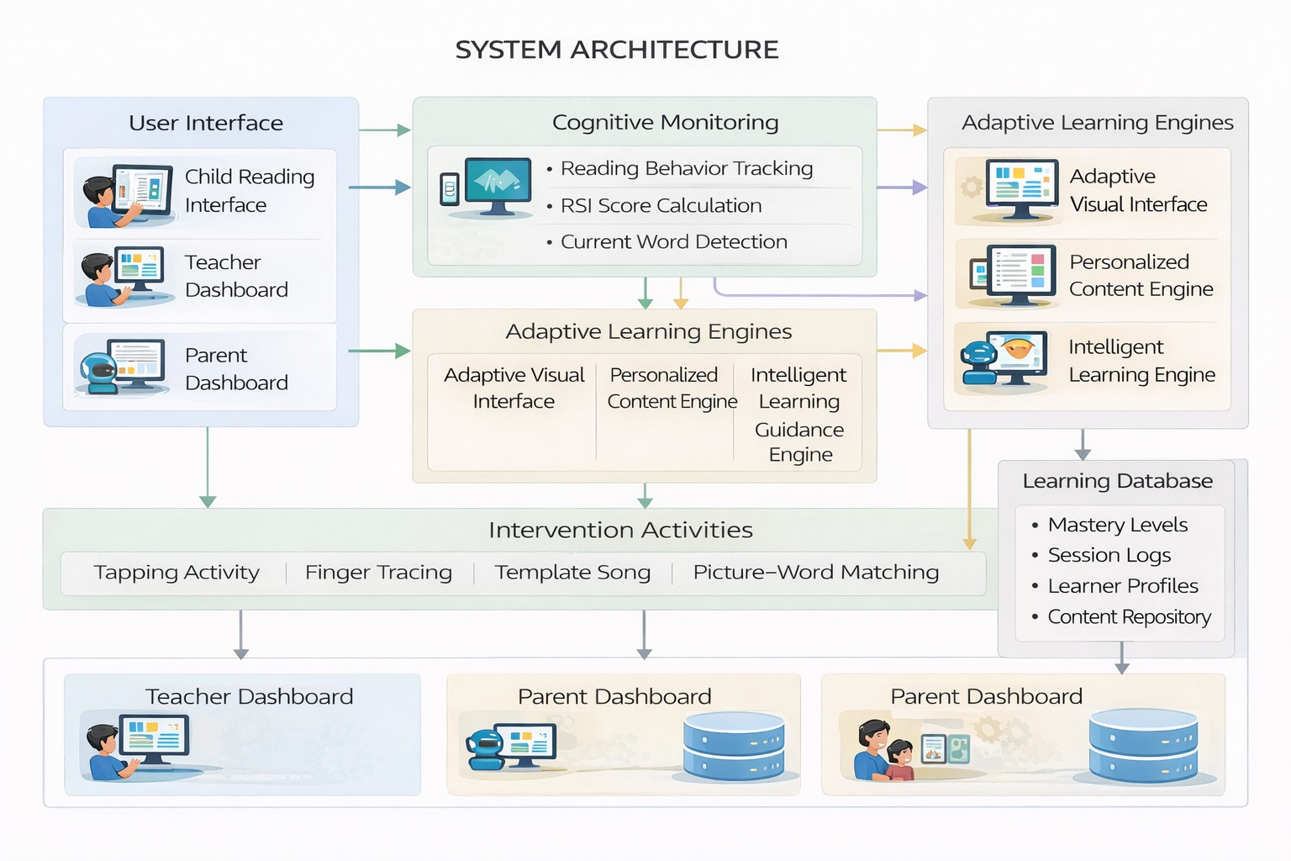
Figure 1: System Architecture — Intelligent Learning Guidance and Intervention

4.2 Data Flow
Before the lesson begins, Model 1 scans every word in the assigned reading passage and stores difficulty predictions in the database. When the child starts reading, Component 1 publishes RSI scores and the current word under gaze focus to a Redis channel every two seconds. The Trigger Detector evaluates threshold conditions on each incoming event. On a Stage 1 trigger, a WebSocket message is sent to the React frontend, which performs a targeted DOM substitution rendering syllable-split bubbles inline within 500 milliseconds. A five-second monitoring window follows. If RSI drops, the child continues reading. If RSI remains elevated, Stage 2 fires: the Phoneme Error Analyser classifies the error type, Model 2 selects the optimal activity for this child, and the activity launches. On completion, the outcome is recorded in the intervention_history table, BKT mastery probabilities are updated, SM-2 review scheduling is checked, and the child is returned to the same word in the same passage.

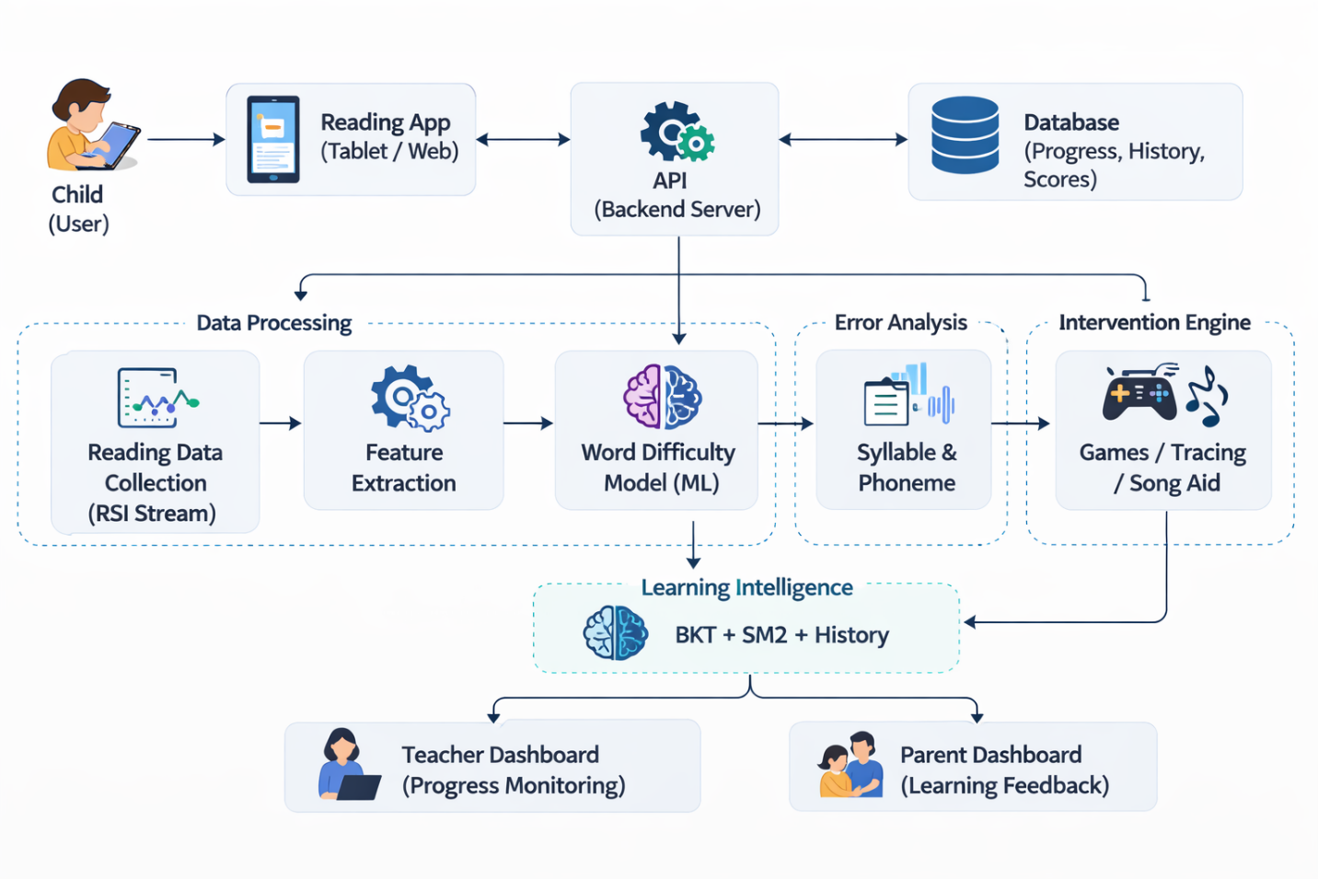
Figure 2: Component Architecture

4.3 Component Interaction Table
Component | Interaction with C4 | Protocol
Component 1 (RSI Monitor) | Streams RSI score + current word + silence duration every 2 seconds | Redis pub-sub
Component 2 (Visual Interface) | Receives WebSocket events to update word display inline | WebSocket (FastAPI)
Component 3 (Content Engine) | Provides current word list and lesson skill level for SM-2 scheduling | Shared PostgreSQL schema
PostgreSQL Learner Model | Stores and retrieves BKT mastery, word history, intervention outcomes, bandit state | SQLAlchemy ORM
Teacher Dashboard | Reads session logs, RSI trends, intervention effectiveness tables via REST API | FastAPI REST endpoint
Parent Dashboard | Reads weekly summary and home activity suggestions via REST API | FastAPI REST endpoint

4.4 Security and Privacy
All API endpoints use JWT-based session tokens. Data in transit is encrypted via TLS. No raw audio recordings are made at any point. Tap, trace, and selection accuracy scores are stored as numeric values only. All child records use pseudonymous ID codes. No personal identifying information is stored in the research database. The system is designed to operate fully offline during reading sessions internet connectivity is required only for initial model downloads, gTTS audio generation, and optional dashboard synchronisation. This offline-first design is essential for deployment in Sri Lankan schools with unreliable internet connectivity.

5. User Requirements

5.1 Stakeholder Identification
Stakeholder | Role | Primary Need
Grade 1 and 2 dyslexic children (ages 6–8) | Primary users — read passages and receive interventions | Inline word-level support in Sinhala or Tamil without leaving the reading passage
Primary school teachers | Monitor per-child progress and adjust classroom instruction | Clear dashboards showing struggling words, intervention history, and skill mastery by child
Parents and caregivers | Support literacy at home without specialist training | Weekly progress summary and simple home activity suggestions in their language
Inclusive education specialists | Validate intervention design and clinical appropriateness | Evidence-based multisensory activity design aligned with dyslexia intervention principles

5.2 Functional Requirements
- The system shall subscribe to the RSI stream from Component 1 and evaluate Stage 1 and Stage 2 trigger conditions every 2 seconds.
- The system shall render syllable-split word bubbles inline in the reading passage within 500 milliseconds of a Stage 1 trigger without reloading the page or navigating away.
- The system shall run Model 1 on every word in the assigned passage before the reading session begins and store difficulty predictions in the learner model database.
- The system shall classify the error type of the struggling word using Unicode-based Phoneme Error Analyser rules and combine this with the Model 1 prediction as input to Model 2.
- The system shall select an intervention activity using Model 2 after the cold-start period, falling back to rule-based mapping during the first three sessions per child.
- The Tapping Game shall display syllable bubbles with beat audio and record per-syllable tap timing accuracy within a 500-millisecond window.
- The Finger Tracing activity shall display a guide path on HTML5 Canvas and measure touch path adherence as the proportion of points within 30 pixels of the path.
- The Template Song shall inject the child's name and the target word into a pre-written template, generate audio using gTTS, and display syllable-synchronised highlights.
- The Picture-Word Match shall present one correct word and two phonologically similar distractors alongside an image, recording selection accuracy.
- Upon completion of any activity, the system shall return the child to the exact same word in the same reading passage without page reload.
- The system shall update BKT mastery probabilities per phonological sub-skill per child after each session and schedule SM-2 reviews when mastery exceeds 0.90.
- The teacher dashboard shall display per-child RSI trend charts, word struggle frequency heatmaps, and intervention effectiveness rates, with a referral alert when average RSI exceeds 7.0 across three consecutive sessions.

5.3 Non-Functional Requirements
Performance:
Stage 1 inline word transformation must render within 500 ms for 95% of triggers under normal load. gTTS audio generation must complete within 2 seconds, and dashboard pages must load within 3 seconds.
Usability:
The child interface must be fully usable by children aged 6–8 using touch input only, with no text instructions. All prompts are delivered as audio in the child’s language, and a new child should be able to complete a reading session within 3 minutes without assistance.
Reliability:
All core features must function offline, with internet required only for initial model downloads and optional dashboard synchronization, supporting environments with unreliable connectivity.
Privacy:
The system does not record raw audio. All child data is pseudonymised, and no personally identifiable information is stored or transmitted externally.
Maintainability:
Model weights and activity templates use semantic versioning. Model 2 retraining can be performed using a single Python script on updated intervention history data without changing application code.

6. Commercialization Plan

6.1 Target Market
The primary target market for the proposed system includes primary schools, special education centers, and parents of children with dyslexia in Sri Lanka. Many schools and parents seek accessible digital learning tools that support children experiencing reading difficulties.
The system is particularly designed for primary school students aged 6–12 years who require additional reading support. Educational institutions can use the platform as a supplementary learning tool to help students improve reading fluency and comprehension.
A typical customer persona includes primary school teachers, special education instructors, and parents who are looking for an effective digital platform that provides personalized literacy exercises and structured reading support for children with dyslexia.

6.2 Value Proposition
The proposed system provides a personalized mobile learning environment specifically designed for students with dyslexia. The platform combines adaptive learning techniques, personalized content selection, and dyslexia-friendly visual presentation to improve reading accessibility and engagement.
By analyzing learner interaction data, the system continuously adapts reading materials and learning activities according to the learner’s performance and reading ability. This approach allows students to practice reading at an appropriate difficulty level while gradually improving literacy skills

6.3 Revenue Model
The system can adopt a subscription-based revenue model where schools or parents subscribe to the platform to access personalized learning features.
Possible revenue streams include:
- Individual user subscriptions for parents who want to support their children’s reading development at home.
- School licensing packages that allow multiple students to access the system within an educational institution.
- Premium educational content packages that provide additional literacy exercises and learning activities.
This model allows the platform to generate sustainable revenue while maintaining accessibility for educational users.

6.4 Cost Estimation
The main costs involved in developing and maintaining the system include:
System Development Costs
Costs related to mobile application development, system design, and implementation of adaptive learning functionalities.
Educational Content Development
Creation of Sinhala reading materials, literacy exercises, and curriculum-aligned educational content.
Cloud Infrastructure Costs
Expenses related to database storage, server hosting, and cloud services used to store learning data and system resources.
Maintenance and Updates
Ongoing system improvements, bug fixes, and updates required to maintain system performance and reliability.

6.5 Pricing Strategy
The pricing strategy is designed to ensure affordability for Sri Lankan schools and families.
Possible pricing plans include:

Plan Type | Target Users | Price Range | Features
Individual Student Plan | Individual students / parents | LKR 500 – LKR 700 per month | Access to personalized learning features and reading exercises
School Plan | Schools and educational institutions | LKR 25,000 – LKR 40,000 per year | Institutional access for multiple students and teachers
Free Basic Version | General users | Free | Limited reading exercises with basic learning features

6.6 Competitive Advantage
The proposed system offers several advantages compared to general digital learning applications:
- Focused support for dyslexic learners rather than general learning platforms.
- Personalized learning content selection based on learner performance.
- Adaptive visual reading interface designed to improve readability for students with dyslexia.
- Mobile-based learning accessibility, allowing students to practice reading anytime and anywhere.
- Content designed specifically for the Sri Lankan primary education context.
These features enable the platform to provide more targeted and effective reading support for students with dyslexia.

6.7 Intellectual Property
The proposed system includes several intellectual property elements that should be protected to support future commercialization.
Software Copyright
The mobile application, system architecture, and implemented algorithms will be protected under software copyright laws.
Educational Content Protection
All literacy exercises, reading passages, and learning materials developed for the system will be protected through copyright.
System Design and Algorithms
The adaptive learning mechanisms and content selection methods may be considered for intellectual property protection to prevent unauthorized use or duplication.
Proper intellectual property protection will help secure the innovation and support long-term commercialization opportunities.

7. Budget and Justification
The total estimated budget is LKR 34,500. The budget is intentionally kept small by using free and open-source tools throughout. scikit-learn, gTTS, FastAPI, PostgreSQL, React, and the Oracle Cloud Free Tier are all available at zero cost. GitHub Education Pack is free for students. The budget therefore covers only the genuine out-of-pocket costs of conducting responsible field research with children — travel to partner schools, consent form printing, participant welfare, and language reviewer honoraria.

No. | Budget Item | Unit Cost (LKR) | Qty | Total (LKR) | Justification
Software Licenses
1 | Python 3.10 + scikit-learn + FastAPI + Redis | Free | — | — | All open-source zero cost. Core ML and API stack for Components 1, 3, and 4 classifiers, REST endpoints, and WebSocket server.
2 | React + Tailwind CSS + Recharts + HTML5 Canvas API | Free | — | — | Open-source front-end stack for Component 2 adaptive UI and Component 4 intervention activities. No licensing fee.
3 | gTTS (Google Text-to-Speech) | Free | — | — | Free Python library. Supports Sinhala (si) and Tamil (ta) locales. Used in Component 4 for syllable audio and Template Song generation. Offline after first run.
4 | PostgreSQL — learner model and content database | Free | — | — | Open-source relational database. Stores BKT mastery, SM-2 schedules, intervention history, RSI logs, and content metadata across all components.
5 | GitHub Education Pack — version control and CI/CD | Free | — | — | Free for SLIIT students. Covers all four component repositories, Actions CI/CD pipelines, and private team collaboration.
6 | Figma — UI wireframes and usability prototypes | Free | — | — | Free student tier. Used for Component 2 visual template design and caregiver/teacher usability testing prototypes.
Cloud Services
7 | Oracle Cloud Free Tier — app hosting and PostgreSQL | Free | — | — | Always-Free tier provides 2 AMD VMs and 20 GB storage sufficient for all four component microservices at research and pilot scale.
8 | Redis Cloud Free Tier — RSI event pub-sub streaming | Free | — | — | 30 MB free Redis instance sufficient for real-time RSI streaming between Component 1 and Components 2, 3, and 4 during pilot sessions.
9 | Internet charges development and pilot study (6 months) | 400 | 6 | 2,400 | LKR 400/month Sri Lanka mobile data plan (~15 GB/month). Covers model downloads, package installs, gTTS API calls, and optional dashboard synchronisation.
Human Effort Costs
10 | Inclusive education specialist — exercise bank review | 3,000 | 1 | 3,000 | One-time review of Component 3 phonological drill bank and Component 4 multisensory activity design for clinical appropriateness and alignment with DSM-5 and ICD-11 dyslexia intervention principles.
11 | Song and poem authoring or copyright clearance | 2,000 | 1 | 2,000 | Commission culturally appropriate Sinhala and Tamil songs and rhymes for Component 4 Template Song activity, or obtain rights clearance. Content mapped to NIE phonological targets for Grade 1 and Grade 2.
12 | NIE curriculum material sourcing and digitization | 2,000 | 1 | 2,000 | Legal procurement, scanning, and digitization of Grade 1–3 Sinhala and Tamil NIE curriculum materials for Component 3 content mapping ontology and Component 4 word difficulty dataset construction.
13 | Ethics consent form printing (English, Sinhala, Tamil) | 30 | 160 | 4,800 | 160 pages: consent and participant information sheets for 20 pilot families across three languages, plus school administrator copies. LKR 30 per page standard Sri Lankan print-shop rate.
14 | Travel to partner schools — all field visits | 950 | 20 | 19,000 | LKR 950 per return visit (bus or tuk-tuk). Component 1 data collection: 6 visits. Component 2 usability testing: 4 visits. Component 4 pilot study, ethics submission, and close-out: 10 visits. Total: 20 visits across the project.
15 | Participant refreshments — pilot study sessions | 250 | 20 | 5,000 | LKR 250 per child per session for snacks and drinks. Ethical best practice for research involving children; builds rapport and reduces attrition across Component 1 and Component 4 sessions.
16 | Stationery, printed forms and field notebooks | 2,500 | 1 | 2,500 | Session observation checklists, researcher field notes, and annotation worksheets used across all four components during data collection and the pilot study.
17 | Contingency reserve (10% of direct cash costs) | — | — | 5,670 | Reserve for unexpected travel, reprinting, additional reviewer sessions, or minor unforeseen needs. Applied only to direct cash outgoings not to zero-cost tools or free hosting services.
TOTAL ESTIMATED BUDGET (LKR) |  |  |  |  | 62,370

9. Work Breakdown Structure
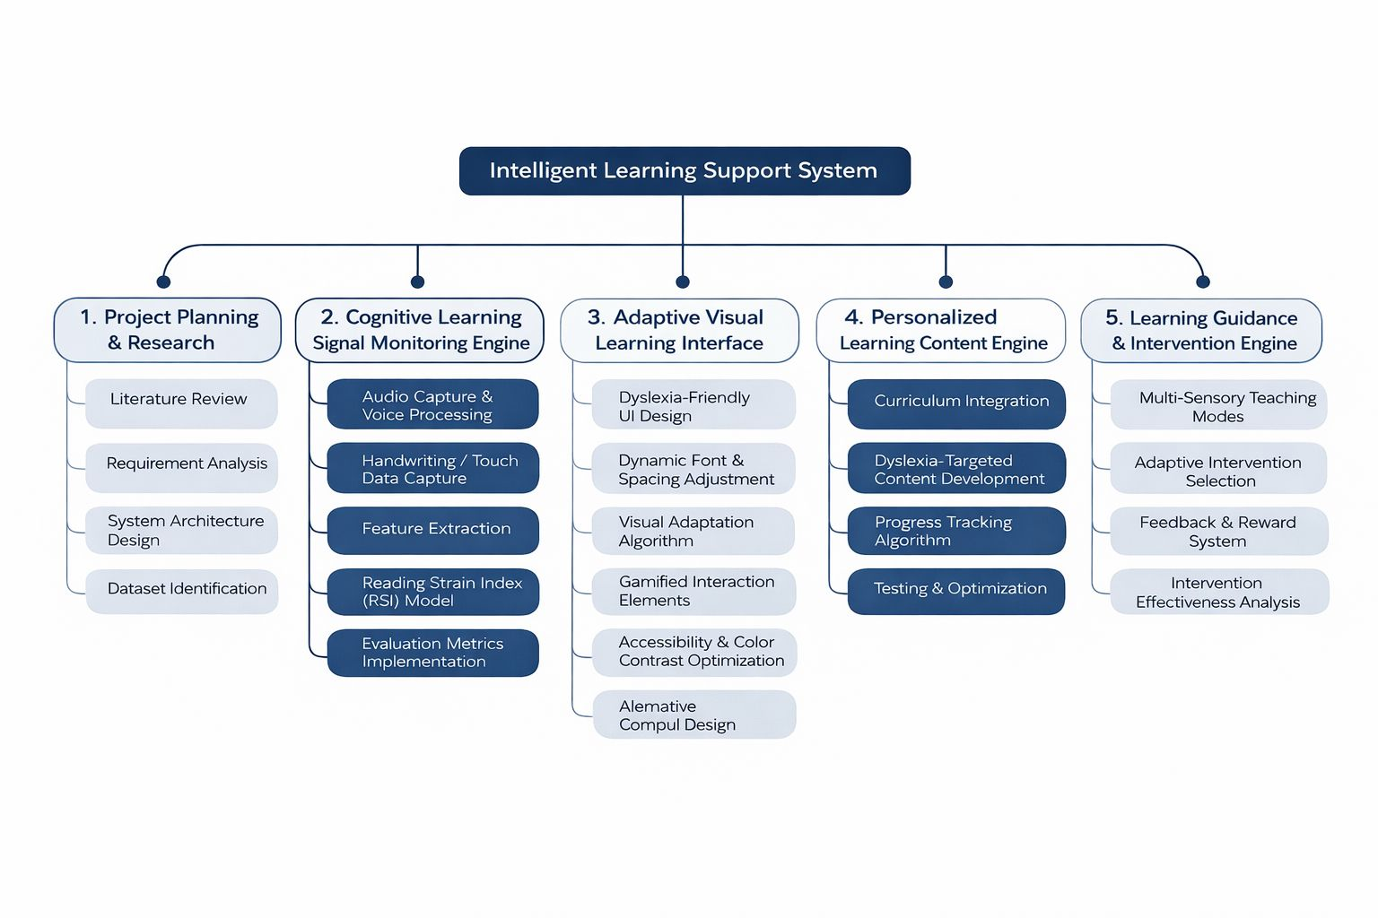

10. Gantt Chart
Phases | March | April |  |  | May |  |  | Jun | Jul | Aug | Sep | Oct | Nov | Dec
Proposal
Design Wireframes & Prototype
Data Collection
Backend Implementation
Data Processing
Model Development
Check List Submission
Progress Presentation 1
Final Check List Submission
Progress Presentation 2
Final Documentation
Website Submission
Final Presentation

11. References
[1] American Psychiatric Association, Diagnostic and Statistical Manual of Mental Disorders, 5th ed. Arlington, VA: APA, 2013.
[2] World Health Organization, International Classification of Diseases, 11th Revision (ICD-11). Geneva: WHO, 2019.
[3] M. J. Snowling, Dyslexia, 2nd ed. Oxford: Blackwell, 2000.
[4] B. Indrarathne, "Primary school teachers' readiness in identifying children with dyslexia: A national survey in Sri Lanka," Dyslexia, vol. 27, no. 4, pp. 456-472, 2021.
[5] S. Fernando et al., "Lived experiences of primary caregivers of children with dyslexia," Children, vol. 11, no. 9, 2024.
[6] U. Goswami, "A neural basis for phonological awareness? An oscillatory temporal-sampling perspective," Current Directions in Psychological Science, vol. 20, no. 4, pp. 252-258, 2011.
[7] A. Bhide, A. Power, and U. Goswami, "A rhythmic musical intervention for poor readers," Mind, Brain, and Education, vol. 7, no. 2, pp. 113-123, 2013.
[8] T. Seneviratne et al., "Arunalu: Learning ecosystem to overcome Sinhala reading weakness due to dyslexia," in Proc. IEEE ICAC, SLIIT, 2020.
[9] S. H. Minoofam, A. Bastanfard, and M. R. Keyvanpour, "RALF: Reinforcement adaptive learning framework for dyslexia," Multimedia Tools and Applications, vol. 81, pp. 14613-14637, 2022.
[10] M. Bedoin et al., "Mila-Learn: A rhythmic video game intervention for children with dyslexia," Scientific Reports, vol. 15, 2025.
[11] A. T. Corbett and J. R. Anderson, "Knowledge tracing: Modeling the acquisition of procedural knowledge," User Modeling and User-Adapted Interaction, vol. 4, no. 4, pp. 253-278, 1994.
[12] H. Ebbinghaus, Memory: A Contribution to Experimental Psychology. New York: Dover, 1885 (reprinted 1964).
[13] A. R. Hevner et al., "Design science in information systems research," MIS Quarterly, vol. 28, no. 1, pp. 75-105, 2004.

Appendices

Appendix A — Research Questions to Metrics Mapping
RQ | Research Question | Metric | Statistical Test
RQ1 | Can Model 1 accurately predict reading difficulty type for Sinhala and Tamil Grade 1 and Grade 2 dyslexic children? | Weighted F1-score, precision, recall per error type class on held-out test set | F1-score comparison across classes; confusion matrix analysis
RQ2 | Does Stage 1 inline syllable splitting reduce word-level decoding time compared to no assistance? | Time to resume reading after stuck event; RSI level 5 seconds post-trigger vs baseline | Independent samples t-test; Group A (Stage 1 enabled) vs Group B (no Stage 1)
RQ3 | Does Model 2 produce better intervention outcomes than fixed rule-based activity mapping? | Mean RSI drop per Stage 2 intervention session; sessions to mastery per phonological target | Independent samples t-test; Mann-Whitney U — Model 2 sessions vs rule-based sessions
RQ4 | Does the system improve phonological skill mastery (BKT) and word retention (SM-2) over 8 weeks? | BKT mastery probability per skill at weeks 1, 4, 8; word recall accuracy at 4-week SM-2 review | Linear regression on mastery curve; paired t-test on 4-week retention scores

